Screenshot 1 using prnt sc
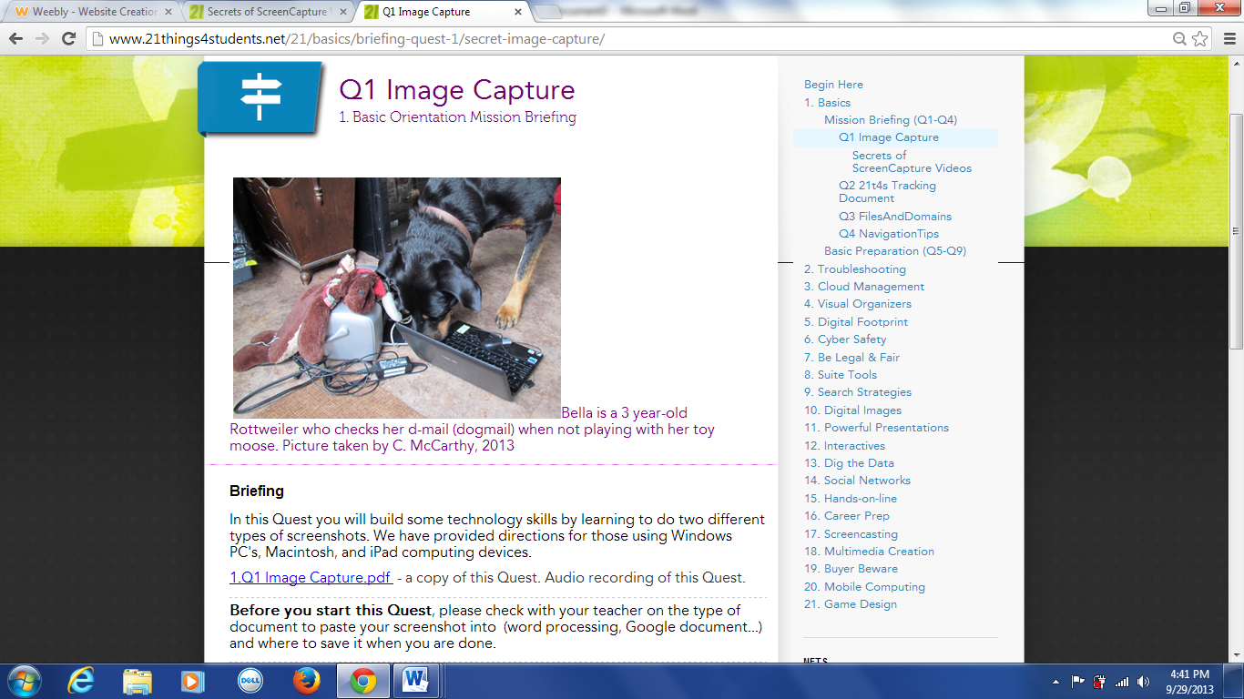
Screenshot 2 with alt-prnt-sc
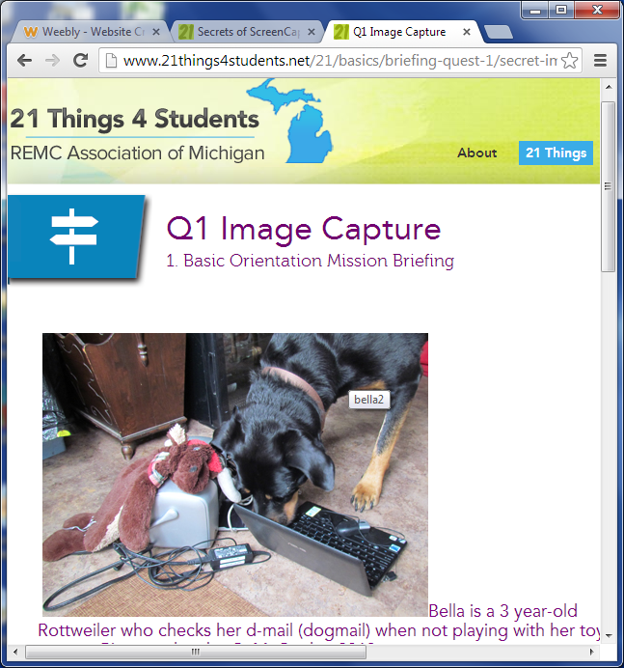
The difference between the two is that alt-prt-sc only captures the open window.
Three ways I can use the screen capture tool is to
Take notes, take the screenshot home on a flash drive, or save a url of my teachers website.

